Project Design Phase-II
Technology Stack (Architecture & Stack)
Date | 20 July 2026
Team ID
Project Name | ShopEZ : E-commerce Application
Maximum Marks | 4 Marks
Technical Architecture
The deliverable includes the architectural diagram below and the information as per Table-1 and Table-2.
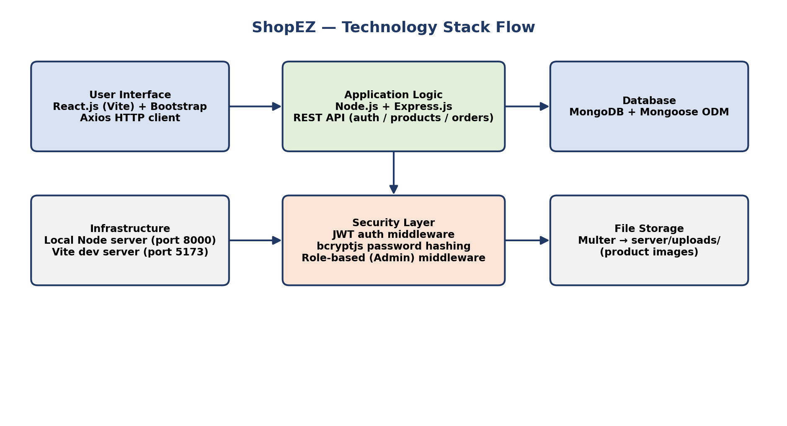
Figure 1: ShopEZ technology stack flow — Client (React) → Application Logic (Express/Node) → Database (MongoDB), with Security and File Storage layers.
Table-1: Components & Technologies
S.No. | Component | Description | Technology
1. | User Interface | How the user interacts with the application. | React.js (Vite), Bootstrap 5, HTML5, CSS3, Axios
2. | Application Logic-1 | Authentication & user management (register, login, JWT, profile). | Node.js, Express.js, authController.js, jsonwebtoken, bcryptjs
3. | Application Logic-2 | Product catalog logic (browse, search, filter, CRUD). | Node.js, Express.js, productController.js, Mongoose
4. | Application Logic-3 | Cart, checkout, and order management (stock decrement, order status). | Node.js, Express.js, orderController.js, Mongoose
5. | Database | Data type, configuration, collections (Users, Products, Orders). | MongoDB (NoSQL, document store), Mongoose ODM
6. | Cloud Database | Database service on cloud for production deployment. | MongoDB Atlas (managed cloud MongoDB cluster)
7. | File Storage | File storage for uploaded product images. | Multer (disk storage) → local server/uploads/, served statically; can migrate to cloud object storage / CDN
8. | External API-1 | Purpose of external API used in the application. | None currently integrated (reserved for a future payment gateway API, e.g. Razorpay/Stripe)
9. | External API-2 | Purpose of external API used in the application. | None currently integrated (reserved for a future shipping/courier tracking API)
10. | Machine Learning Model | Purpose of Machine Learning model. | Not used in the current version
11. | Infrastructure (Server / Cloud) | Application deployment on local system / cloud.  Local Server Configuration: Node.js v18+, MongoDB (local instance), npm.  Cloud Server Configuration: Node.js hosting (e.g. Render/Railway), MongoDB Atlas, static hosting/CDN for the React build. | Local: Node.js runtime; Cloud: Render / Railway / AWS EC2, MongoDB Atlas, Vercel/Netlify for frontend
Table-2: Application Characteristics
Characteristics | Description | Technology
Open-Source Frameworks | React.js, Express.js, Mongoose, Bootstrap — all open-source frameworks/libraries used across the stack. | React.js, Express.js, Mongoose, Bootstrap
Security Implementations | Passwords hashed with bcrypt before storage; stateless authentication via signed JWTs (7-day expiry); role-based route protection (authMiddleware, adminMiddleware); CORS restricted to the app's own frontend; environment secrets kept in .env (not committed). | bcryptjs, JSON Web Tokens (JWT), CORS, dotenv
Scalable Architecture | 3-tier architecture (React client / Express API / MongoDB) with clean separation of routes, controllers, and models, allowing the API and database to be scaled independently as load grows. | MERN 3-tier architecture
Availability | Stateless JWT-based API allows multiple Express instances to run behind a load balancer without shared session state; MongoDB Atlas supports replica sets for high availability. | Load balancer + stateless API, MongoDB Atlas replica set
Performance | Indexed MongoDB queries (e.g. on product name/category), client-side cart persisted in local storage to avoid extra round-trips, and Vite's fast bundling/HMR for the frontend; static image serving can be offloaded to a CDN. | MongoDB indexing, Vite, CDN (future)
References
https://c4model.com/
https://www.ibm.com/cloud/architecture
https://aws.amazon.com/architecture

